QUESTION : Assignment 4
Consider the following table: Table: CLASS
ID Name
1 Bravo
2 Alex
4 Cheng

Give the output of the following SQL script:
•⁠ ⁠INSERT INTO class VALUES (5,’Rahul’);
•⁠ ⁠COMMIT;
•⁠ ⁠UPDATE class SET name = ‘Abhijeet’ WHERE id= ‘5’;
•⁠ ⁠SAVEPOINT A;
•⁠ ⁠INSERT INTO class VALUES (6, ‘Chris’);
•⁠ ⁠SAVEPOINT B;
•⁠ ⁠INSERT INTO class VALUES (7, ‘Bravo’);
•⁠ ⁠SAVEPOINT C
•⁠ ⁠SELECT * FROM class;
•⁠ ⁠ROLLBACK TO B;
•⁠ ⁠SELECT * FROM class;
•⁠ ⁠ROLLBACK TO A;

CODE :

SET autocommit = 0;

CREATE TABLE class (
id INT,
name VARCHAR(50)
);

INSERT INTO class VALUES (1,'Bravo');
INSERT INTO class VALUES (2,'Alex');
INSERT INTO class VALUES (4,'Cheng');

INSERT INTO class VALUES (5,'Rahul');
COMMIT;

UPDATE class SET name='Abhijeet' WHERE id='5';

SAVEPOINT A;

INSERT INTO class VALUES (6,'Chris');

SAVEPOINT B;

INSERT INTO class VALUES (7,'Bravo');

SAVEPOINT C;

SELECT * FROM class;

ROLLBACK TO B;

SELECT * FROM class;

ROLLBACK TO A;

Table :

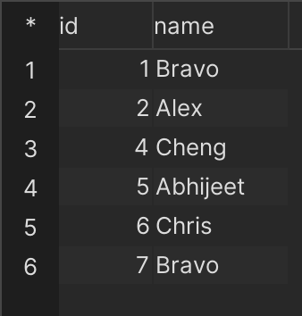

Assignment (4.2)

Consider the following table: Table: ACCOUNT_TXN

Acc_ID Holder_Name Balance
101 Aman 5000
102 Bhavna 7000
103 Chirag 6000
Perform the following TCL-based SQL script and write the output after each SELECT statement:

CODE :

CREATE TABLE ACCOUNT_TXN (
Acc_ID INT,
Holder_Name VARCHAR(50),
Balance INT
);

INSERT INTO ACCOUNT_TXN VALUES (101,'Aarav',5000);
INSERT INTO ACCOUNT_TXN VALUES (102,'Bhavna',6000);
INSERT INTO ACCOUNT_TXN VALUES (103,'Chirag',7000);

SET autocommit = 0;

INSERT INTO ACCOUNT_TXN VALUES (104,'Diya',4000);

UPDATE ACCOUNT_TXN SET Balance = Balance +1500 WHERE Acc_ID=101;

UPDATE ACCOUNT_TXN SET Balance = Balance -1000 WHERE Acc_ID=102;

SAVEPOINT S2;

DELETE FROM ACCOUNT_TXN WHERE Acc_ID=103;

INSERT INTO ACCOUNT_TXN VALUES (105,'Eshan',3000);

SAVEPOINT S3;

UPDATE ACCOUNT_TXN
SET Holder_Name='Bhavna Sharma'
WHERE Acc_ID=102;

SELECT * FROM ACCOUNT_TXN;

ROLLBACK TO S2;

SELECT * FROM ACCOUNT_TXN;

INSERT INTO ACCOUNT_TXN VALUES (106,'Farah',4500);

SAVEPOINT S4;

UPDATE ACCOUNT_TXN
SET Balance = Balance +500
WHERE Acc_ID IN (101,104);

SELECT * FROM ACCOUNT_TXN;

SELECT * FROM ACCOUNT_TXN;

COMMIT;

OUTPUT :

